Nash Allan-Rahill, MS4
I’m so grateful to the NHAFP for making it possible for me to attend the AAFP Futures Conference! I never imagined how much I would gain from this experience—it really helped me learn about different family medicine residency programs and figure out what matters most to me in a future program. The chance to meet students and residents from across the country was heartwarming and reaffirmed that family medicine is where I belong. Thank you for supporting such a valuable experience!
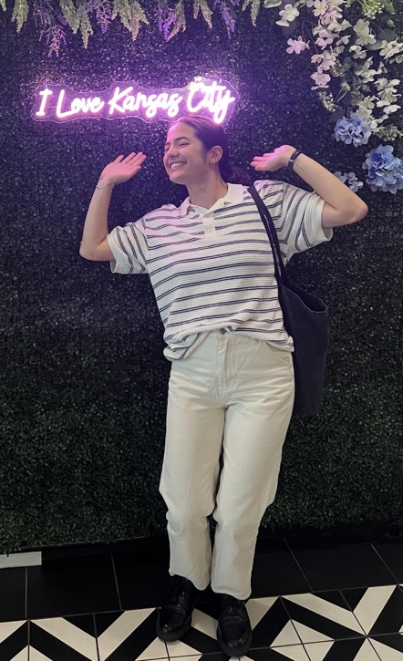
Daniella Azulai, MS4
Attending the FUTURE conference was an incredible experience. I was able to connect with programs I knew I was interested in (and some I didn’t even know I was interested in!) and learn more about nuances of the residencies specific to my interests. The energy in the expo hall and small groups was infectious - I came away from the conference more excited than ever to be applying into Family Medicine. There were even happy hours after the conference where we were able to meet with faculty and students in an informal setting and share stories and laughs. I am beyond grateful for the opportunity to attend the FUTURE conference without worrying about the economic burden - thank you!

Sarah Curtis, MS4
I had an amazing time attending the AAFP future conference. It was such an important experience to connect with various residency programs before I apply. Additionally, I learned so much from the various workshops I attended including how to taper and switch opioid medications, manage postpartum hemorrhage, and dose gender affirming hormone therapy. I would not have been able to attend without the support of the NH AFP. Thank you so much for allowing me to access this opportunity.

Katie Hartnett, MS4
I am so grateful to have been able to attend the AAFP FUTURES conference, thanks to the support of the NH AFP. Of course, there was much time spent learning about different residency programs, getting to learn the nuances of different approaches to training and starting to build my professional network. I was impressed by how many amazing people there are in the field of Family Medicine, and I left the conference feeling really excited to formally join this community.
Lastly, I appreciated attending some of the educational sessions, one in particular on financial planning going into residency felt relevant and incredibly helpful. Thanks for your support, it was a really enriching and valuable experience.

Grace Palmer, MS4
I am very grateful for my experience at AAFP FUTURES conference and so thankful for the generosity of the NH AFP. The conference had so much to offer. I attended 2 amazing hands-on workshops on wound care (identifying wounds, dressing selection, foot care, unna boot dressings) and obstetrics (postpartum hemorrhage management, practice cervical checks, cervical ripening balloon placement, complex vaginal laceration repair). The workshops were so informative that I wish they could be incorporated into our training at Geisel. I spent most of my conference time at the residency fair. It was extremely helpful to talk to residency programs and get a better sense of where I want to apply and what things I want out of my residency training. It was very motivating to meet so many people who were also passionate about family medicine, and all of the wonderful career paths available. It felt confirming of my decision to apply into Family Medicine!

